Guess The Number Game

Documentation

Module Name

main.py

Description
This Python program is an interactive number guessing game. The user selects a range, and the program generates a random number within that range. The player guesses the number, receives feedback and hints, and earns scores. The game supports multiple rounds with a cumulative scoring system.

Functions Overview

1. print_banner()
Displays the welcome banner at the start of the game.

2. get_range()
Takes the starting and ending values of the guessing range from the user, validates the input, and returns a valid range.

3. generate_random_number(start, end)
Generates and returns a random number within the given range.

4. get_user_guess()
Prompts the user to enter a guess and ensures valid integer input.

5. calculate_distance(guess, target)
Calculates the absolute difference between the guessed number and the target number.

6. show_feedback(guess, target)
Provides feedback such as very close, close, or far off and indicates whether the target number is higher or lower.

7. retry_prompt()
Asks the user whether they want to play another round and returns a boolean value.

8. show_instructions()
Displays the rules and instructions of the game.

9. show_summary(round_number, attempts, round_score, total_score)
Displays a summary of the completed round including attempts and scores.

10. play_game()
Controls the main game flow including range input, guessing loop, scoring, and round management.

11. main()
Entry point of the program. Displays the banner and starts the game.

Scoring System
- Maximum score per round = (end − start + 1)
- Score decreases with each wrong guess
- Minimum score = 0
- Total score accumulates across rounds

Game Flow
- Display banner
- Show instructions
- Get range
- Generate random number
- Guess until correct
- Show round summary
- Ask to play again
- Display final score

Dependencies
- random – Random number generation
- time – Delay handling

Flowchart
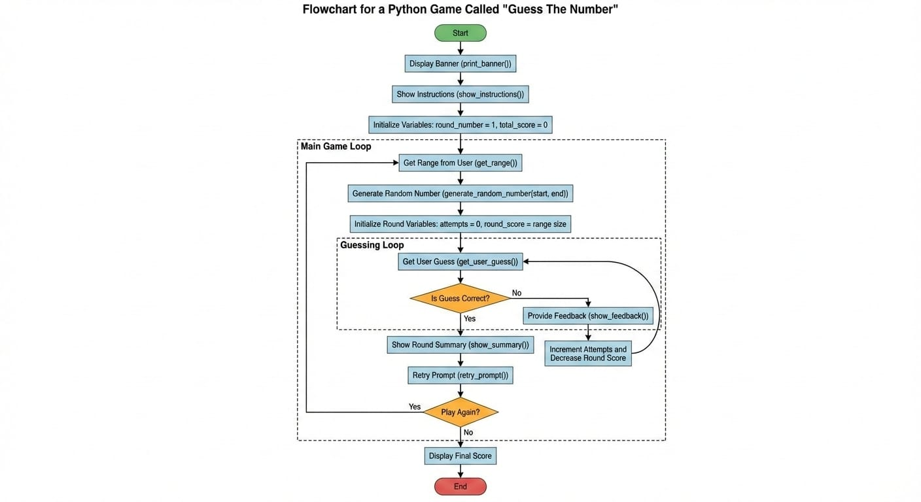

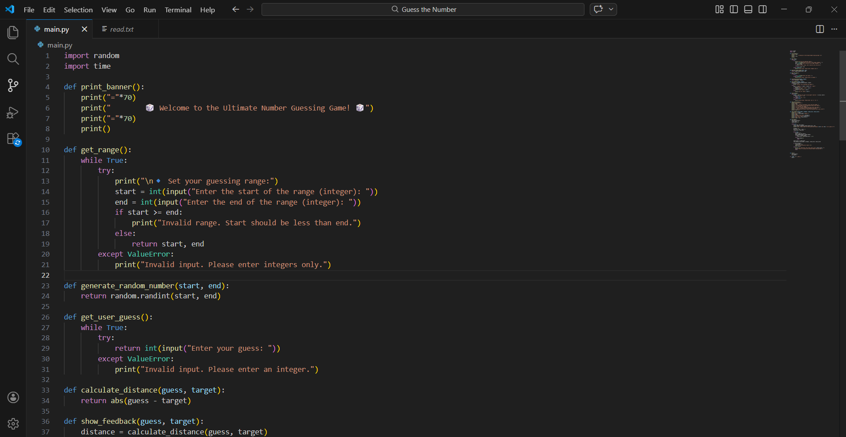
Source Code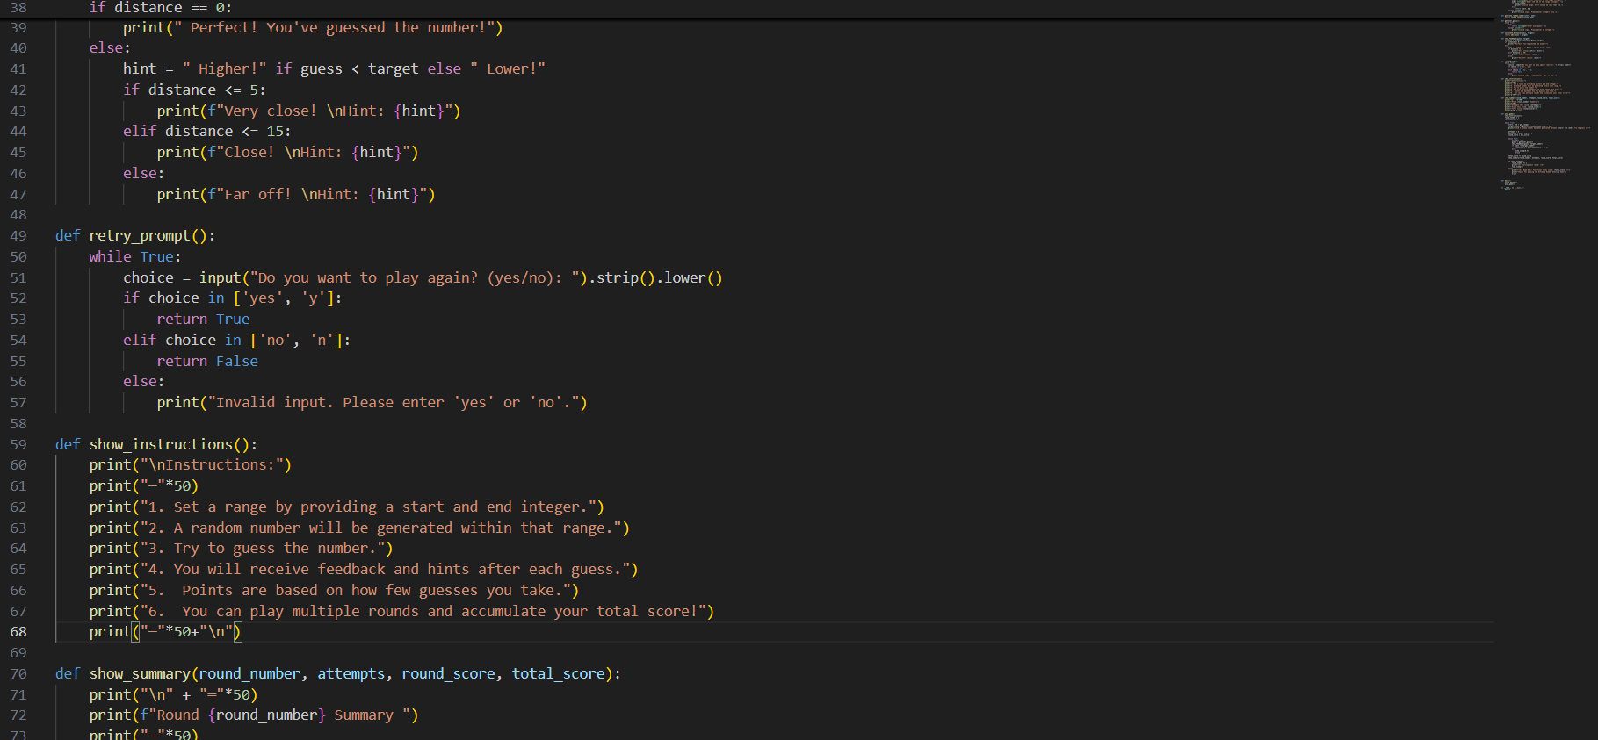
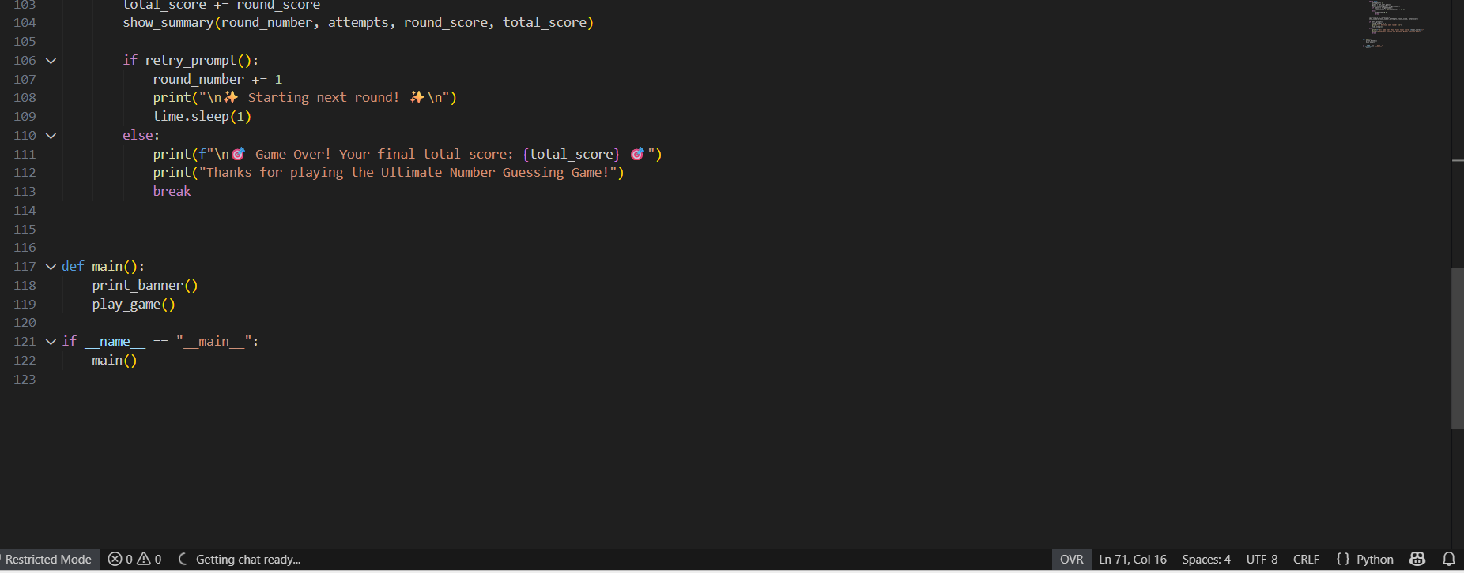
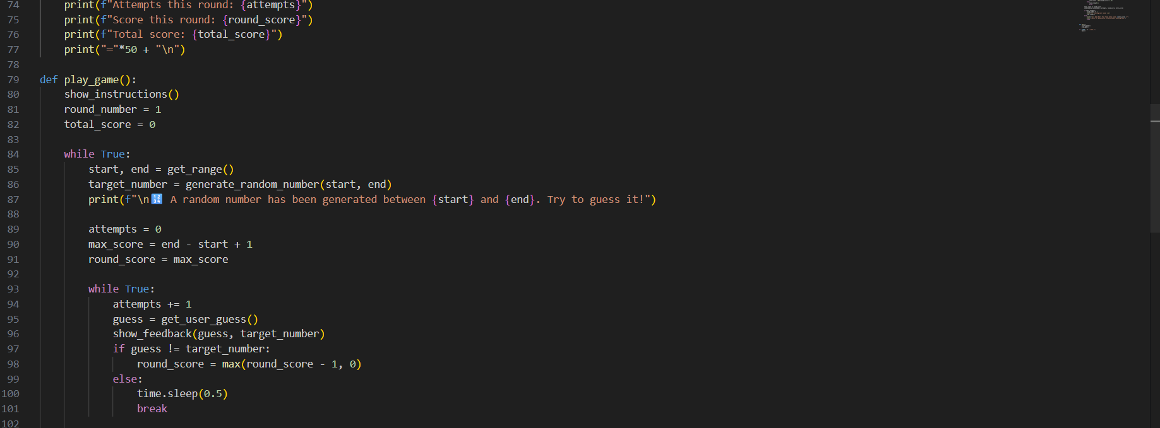

Output (Sample)
